ESO203A_TUT 9 31.3.17

Q1: A 460V 56kW,6 Pole, class D Squirrel cage motor has a full load slip of 15%.The approximate equivalent circuit of the motor is shown in the figure.
.
The motor drives a centrifugal pump whose characteristic is 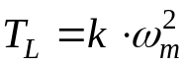.The pump requires 285N-m when operating at 1500 RPM.
Calculate the speed at which the pump operates when supplied from 460V, 50Hz source.(b) Calculate approximately the speed range over which the pump can operate ,if the input voltage can be decreased by additional apparatus.

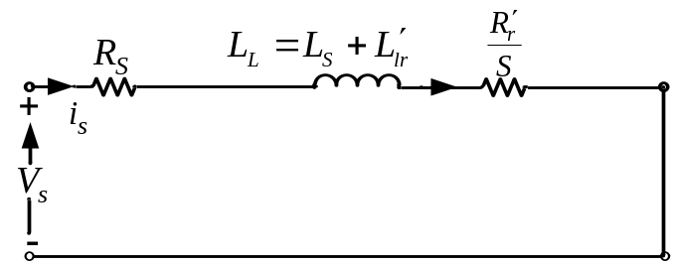

[974.5 RPM, 974.5 to 300 RPM]
Q2: An induction motor has the following specifications.
5kW, 415V, 6 Pole, 3 phase, 50Hz, 0.8 p.f., Star-connected. The following test data is available.
NO LOAD TEST: Applied voltage 415V, line current 3.5A, Input power 250W.
The measured stator resistance per phase is 1.5Ω.
BLOCKED ROTOR TEST: Applied voltage 115V, line current 13A, Input power 1660W.
Making suitable assumptions calculate the following.
(a)Core, Friction and Windage losses.(b) Magnetizing impedance(c)Rotor resistance referred to stator (d) Total leakage reactance.
[194.7W, R_{m}=684.5 Ohms, X_{m}=68.3Ohms,1.77Ohms,3.92Ohms]
Q3: The motor of Q2 is operated from a 415V supply. The input line current is 9.6A and power is 6kW.The slip speed is 40RPM.
Calculate the power factor, torque, speed and efficiency at this operating point.
[0.87,51.47N-m,960RPM,86.24%]
Q4: An induction motor develops 50 HP with an efficiency of 90%.At this operating point the stator copper loss, the rotor copper loss and iron losses are equal. The mechanical losses are 33% of the no load loss. Calculate the slip.
[3.03%]
Q5: A 12 pole, three phase 50Hz induction motor draws 250A and 100kW when started from stand still. The stator resistance (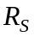) can be assumed to be equal to the referred rotor resistance (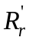).Calculate the starting torque.
[966.87N-m]

